**1)** **To write a program to measure the distance using ultrasonic sensor and make LED blink using Arduino.**

**1.Schematic:**

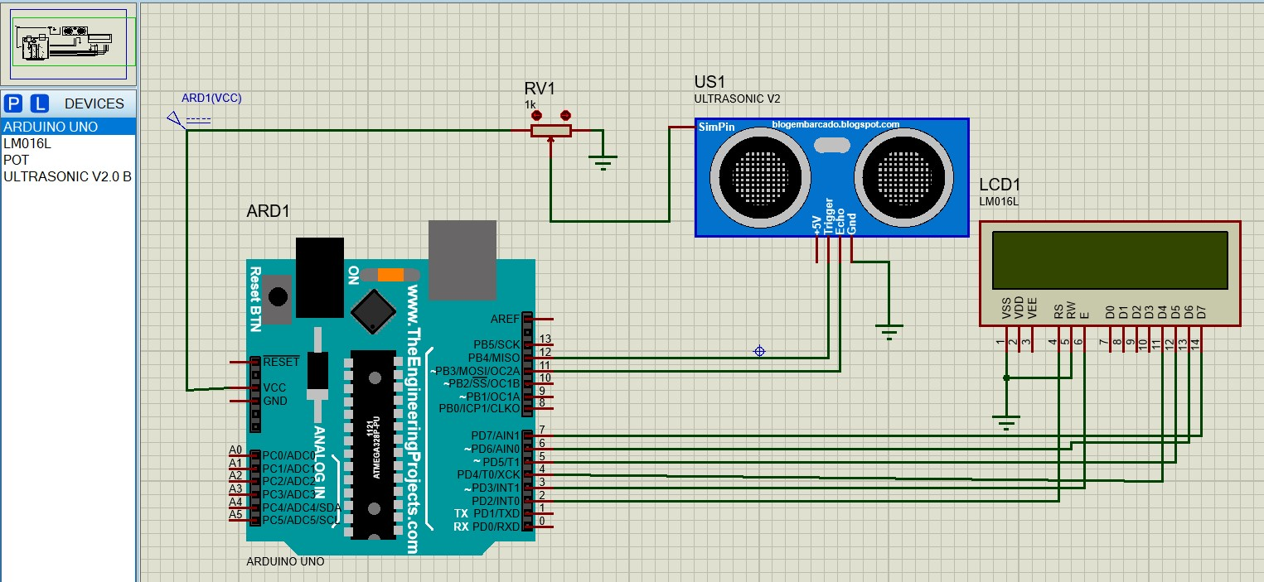

**2.Program: distance_measure.ino**

// include the library code:

#include <LiquidCrystal.h> //library for LCD

// initialize the library with the numbers of the interface pins LiquidCrystal lcd(13, 12, 11, 10, 9, 8);

// defines pins numbers

const int trigPin = 2; const int echoPin = 3;

// defines variables long duration; int distance;

void setup()

{

pinMode(trigPin, OUTPUT); // Sets the trigPin as an Output pinMode(echoPin, INPUT); // Sets the echoPin as an Input

lcd.begin(20, 4); // set up the LCD's number of columns and rows: lcd.setCursor(0,0); // set the cursor position:

lcd.print(" THE BRIGHT LIGHT "); lcd.setCursor(0,1); lcd.print("DISTENCE MEASUREMENT ");

}

void loop()

{

// Clears the trigPin digitalWrite(trigPin, LOW); delayMicroseconds(2);

// Sets the trigPin on HIGH state for 10 micro seconds digitalWrite(trigPin, HIGH); delayMicroseconds(10); digitalWrite(trigPin, LOW);

// Reads the echoPin, returns the sound wave travel time in microseconds duration = pulseIn(echoPin, HIGH);

// Calculating the distance in cm distance = duration*0.034/2;

// Adust the distance Range (2cm to 400cm) int D = map(distance, 10, 1095, 2, 400);

// Prints the distance on the LCD lcd.setCursor(0,2); lcd.print(" Distance: "); lcd.print(D); lcd.print("cm "); lcd.setCursor(0,3); lcd.print(" Distance: "); lcd.print(D/30.48);

lcd.print("ft ");

}

**3.OUTPUT:**

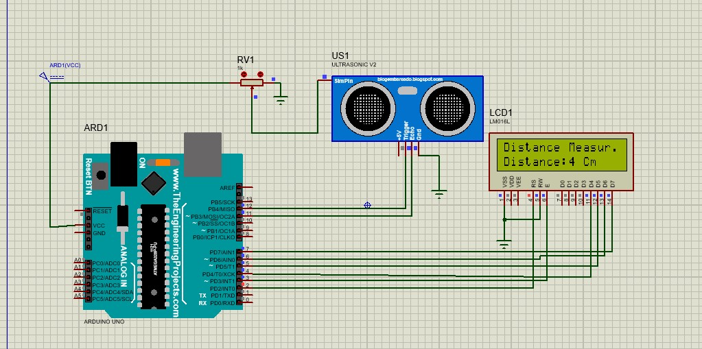

**2)** **To write a program to detects the vibration of an object with sensor using Arduino.**

**1.Schematic:**

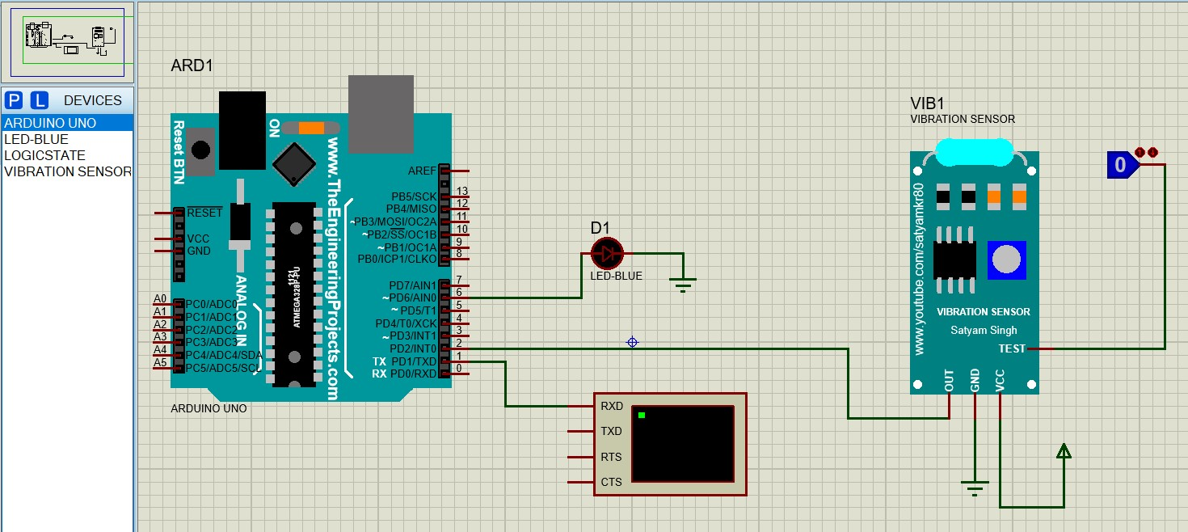

**2.Program:**

int b1 = 2; int d1 = 5; int cnt=0,cnt2; int timer=0;

// a maximum of eight servo objects can be created int pos = 0; // variable to store the servo position void setup() {

Serial.begin(9600); //initialize serial

pinMode(b1, INPUT_PULLUP); pinMode(d1, OUTPUT); digitalWrite(d1, HIGH); digitalWrite(d1,LOW);

delay(300); // wait for a second cnt=0;

}

void loop() {

if(digitalRead(b1) == HIGH){ Serial.println("VIBRATION ALERT"); digitalWrite(d1, HIGH);

delay(300); // wait for a second

digitalWrite(d1, LOW);

delay(300); // wait for a second digitalWrite(d1, HIGH);

delay(300); // wait for a second

digitalWrite(d1, LOW);

delay(300); // wait for a second digitalWrite(d1, HIGH);

delay(300); // wait for a second

digitalWrite(d1, LOW);

delay(300); // wait for a second

}

}

**3.OUTPUT:**

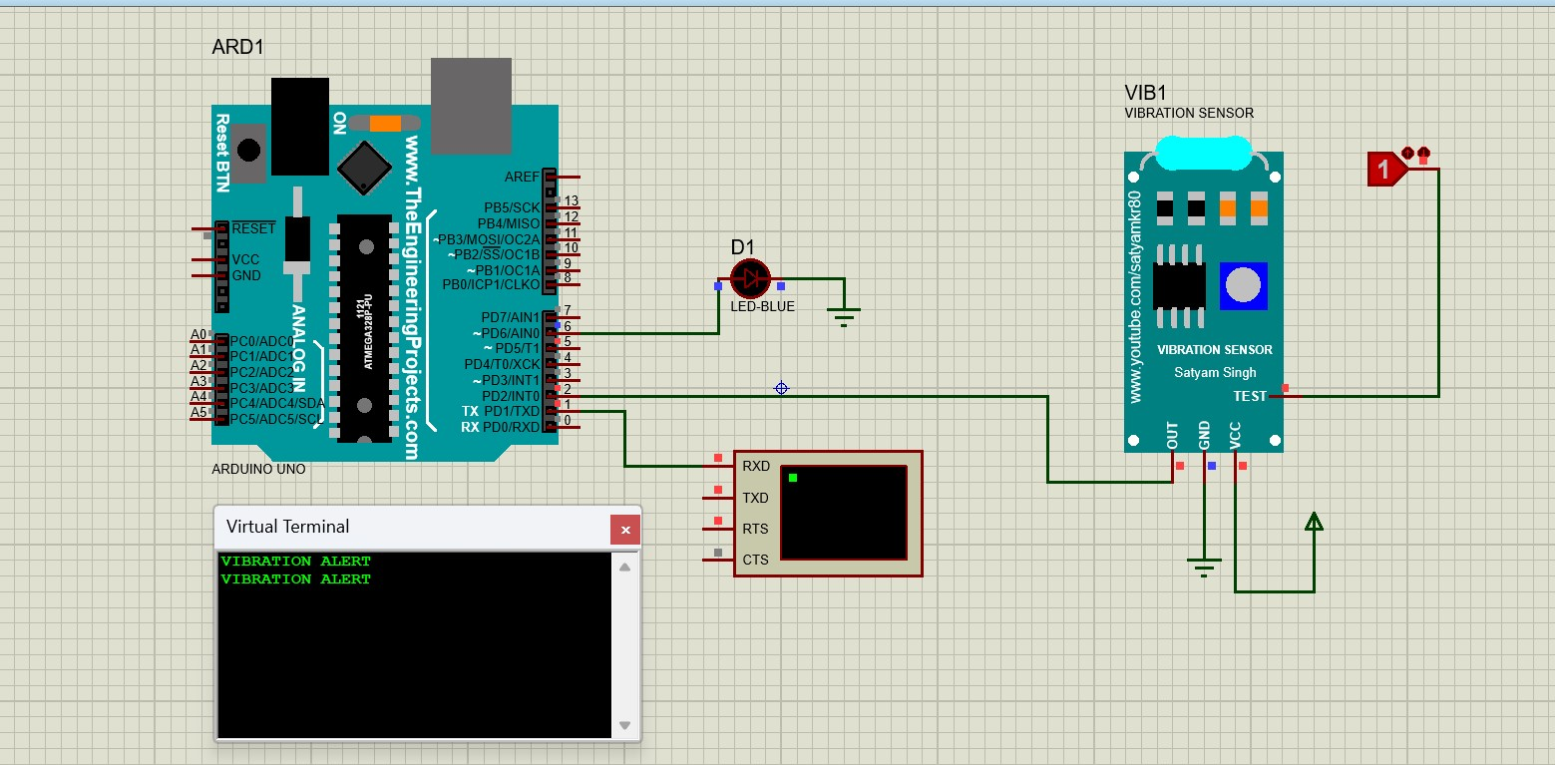

**3)** **To write a program to sense a finger when it is placed on the board Arduino**

**1.Schematic:**

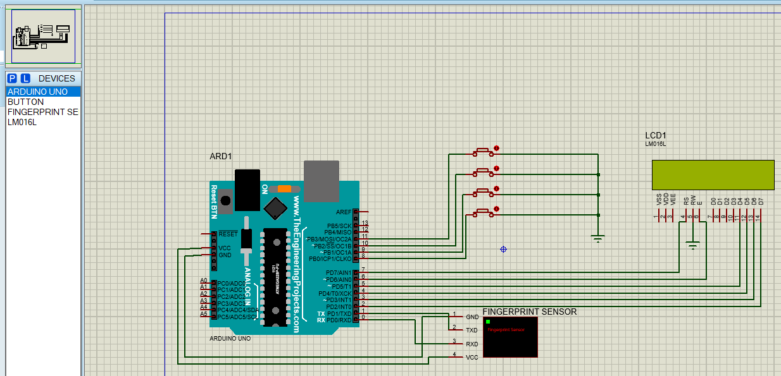

**2.Program:**

#include <LiquidCrystal.h>

#include <Adafruit_Fingerprint.h>

#include <SoftwareSerial.h> #include <EEPROM.h>

const int buttonPin8 = 8; // the number of the pushbutton pin const int buttonPin9 = 9; // the number of the pushbutton pin const int buttonPin10 = 10; // the number of the pushbutton pin const int buttonPin11 = 11; // the number of the pushbutton pin

//const int ledPin = 13; // the number of the LED pin

LiquidCrystal lcd(7, 6, 5, 4, 3, 2); // initialize the library with the numbers of the interface pins int buttonState8 = 0; int buttonState9 = 0; int buttonState10 = 0;

int buttonState11 = 0; uint8_t id =1; uint8_t id_used =0; int key= 0;

uint8_t getFingerprintEnroll();

//SoftwareSerial mySerial(11, 12);

Adafruit_Fingerprint finger = Adafruit_Fingerprint(&Serial);

void setup() {

pinMode(buttonPin8, INPUT_PULLUP); pinMode(buttonPin9, INPUT_PULLUP); pinMode(buttonPin10, INPUT_PULLUP); pinMode(buttonPin11, INPUT_PULLUP);

lcd.begin(16, 2); lcd.print(" FINGERPRINT"); lcd.setCursor(0, 1);

lcd.print("ATTENDANCE DEMO");

delay(500); finger.begin(57600);

}

void loop() {

showmenu();

while((key = getkey()) == 0);

if (key == 1) { id = getid(); if(id == 0)

{

lcd.clear();

lcd.setCursor(0, 0); lcd.print("No space"); lcd.setCursor(0, 1); lcd.print("Del templetes"); delay(1000); }else{

getFingerprintEnroll();

}

delay(1500);

} else if (key == 2) { getFingerprintID(); delay(1500);

} else if (key == 3) {

showDelmenu();

delay(1500); } else if (key == 4) { lcd.clear(); lcd.setCursor(0, 0); lcd.print("Credits:"); delay(500); lcd.clear(); lcd.setCursor(0, 0);

lcd.print(“");

lcd.setCursor(0, 1); lcd.print("BROTI"); delay(1000);

}else {

//lcd.clear();

}

}

void showmenu()

{

lcd.clear(); lcd.setCursor(0, 0); lcd.print("1:Enroll 2:Scan "); lcd.setCursor(0, 1); lcd.print("3:Del ");

}

void showDelmenu()

{

lcd.clear(); lcd.setCursor(0, 0); id_used = getUsedIdnext(); lcd.print("ID <");lcd.print(id_used);lcd.print(">"); lcd.print(" 1:Del"); lcd.setCursor(0, 1); lcd.print("2:Up 3:Dn 4:Back"); while(getkey()!=4)

{

if(getkey()==2)

{

while(getkey()==2); id_used = getUsedIdnext(); lcd.setCursor(0, 0); lcd.print("ID <");lcd.print(id_used);lcd.print("> 1-Del");

}else if(getkey()==3){ while(getkey()==3); id_used = getUsedIdprev(); lcd.setCursor(0, 0); lcd.print("ID <");lcd.print(id_used);lcd.print("> 1-Del");

}else if(getkey()==1){ while(getkey()==1); deleteFingerprint(id_used); unreserveId(id_used); id_used = getUsedIdprev(); lcd.setCursor(0, 0); lcd.print("ID <");lcd.print(id_used);lcd.print("> 1-Del");

}

}

}

int getkey()

{

if( digitalRead(buttonPin8)){ while( digitalRead(buttonPin8));

return 1;

}else if(digitalRead(buttonPin9)){ while( digitalRead(buttonPin9));

return 2;

}else if(digitalRead(buttonPin10)){ while( digitalRead(buttonPin10));

return 3;

}else if(digitalRead(buttonPin11)){ while( digitalRead(buttonPin11));

return 4;

}else{return 0;}

}

int getid(){ for(id = 1 ;id <=160;id++)

{

if(EEPROM.read(id)==0)

{

return id;

}

}

if(id>160)

{

return 0;

}

}

int getUsedIdnext()

{

for(;id_used<=160;)

{

id_used++; if(EEPROM.read(id_used)==1)

{

return id_used;

}

}

if(id_used>160)

{

return 0;

}

return id_used;

}

int getUsedIdprev()

{

if(id_used>1) for(;id_used>0;)

{

id_used--;

if(EEPROM.read(id_used)==1)

{

return id_used;

}

}

if(id_used>160)

{

return 0;

}

return id_used;

}

void reserveId(int id){ EEPROM.write(id,1);

}

void unreserveId(int id){

EEPROM.write(id,0);

}

uint8_t getFingerprintEnroll() {

int p = -1; lcd.print("Waiting for finger"); while (p != FINGERPRINT_OK) {

p = finger.getImage(); switch (p) {

case FINGERPRINT_OK:

lcd.clear();

lcd.print("Image taken");

break;

case FINGERPRINT_NOFINGER:

lcd.clear(); lcd.print("."); break;

case FINGERPRINT_PACKETRECIEVEERR:

lcd.clear();

lcd.print("Communication error");

break;

case FINGERPRINT_IMAGEFAIL:

lcd.clear();

lcd.print("Imaging error");

break; default: lcd.clear();

lcd.print("Unknown error");

break;

}

p = finger.image2Tz(1); switch (p) {

case FINGERPRINT_OK:

lcd.clear();

lcd.print("Image converted");

break;

case FINGERPRINT_IMAGEMESS:

lcd.clear();

lcd.print("Image too messy");

return p;

case FINGERPRINT_PACKETRECIEVEERR:

lcd.clear();

lcd.print("Communication error");

return p;

case FINGERPRINT_FEATUREFAIL:

lcd.clear();

lcd.print("Could not find fingerprint features");

return p;

case FINGERPRINT_INVALIDIMAGE:

lcd.clear();

lcd.print("Could not find fingerprint features");

return p; default: lcd.clear();

lcd.print("Unknown error");

return p;

}

lcd.clear();

lcd.print("Remove finger"); delay(2000);

p = 0;

while (p != FINGERPRINT_NOFINGER) {

p = finger.getImage();

}

lcd.clear(); lcd.print("ID ");lcd.print(id); p = -1; lcd.clear();

lcd.print("Place same finger again"); while (p != FINGERPRINT_OK) {

p = finger.getImage(); switch (p) {

case FINGERPRINT_OK:

lcd.clear();

lcd.print("Image taken");

break;

case FINGERPRINT_NOFINGER:

lcd.clear(); lcd.print("."); break;

case FINGERPRINT_PACKETRECIEVEERR:

lcd.clear();

lcd.print("Communication error");

break;

case FINGERPRINT_IMAGEFAIL:

lcd.clear();

lcd.print("Imaging error");

break; default: lcd.clear();

lcd.print("Unknown error");

break;

}

}

p = finger.image2Tz(2); switch (p) {

case FINGERPRINT_OK:

lcd.clear();

lcd.print("Image converted");

break;

case FINGERPRINT_IMAGEMESS:

lcd.clear();

lcd.print("Image too messy");

return p;

case FINGERPRINT_PACKETRECIEVEERR:

lcd.clear();

lcd.print("Communication error");

return p;

case FINGERPRINT_FEATUREFAIL:

lcd.clear();

lcd.print("Could not find fingerprint features");

return p;

case FINGERPRINT_INVALIDIMAGE:

lcd.clear();

lcd.print("Could not find fingerprint features");

return p;

default: lcd.clear();

lcd.print("Unknown error");

return p;

}

// OK converted!

lcd.clear();

lcd.print("Creating model #");lcd.print(id);

p = finger.createModel(); if (p == FINGERPRINT_OK) {

lcd.clear();

lcd.print("Prints matched!");

} else if (p == FINGERPRINT_PACKETRECIEVEERR) {

lcd.clear();

lcd.print("Communication error");

return p;

} else if (p == FINGERPRINT_ENROLLMISMATCH) {

lcd.clear();

lcd.print("Fingerprints did not match"); return p; } else { lcd.clear();

lcd.print("Unknown error");

return p;

}

lcd.clear();

lcd.print("ID ");lcd.print(id); p = finger.storeModel(id); if (p == FINGERPRINT_OK) {

lcd.clear(); lcd.print("Stored at id ");lcd.print(id); reserveId(id);

} else if (p == FINGERPRINT_PACKETRECIEVEERR) {

lcd.clear();

lcd.print("Communication error");

return p;

} else if (p == FINGERPRINT_BADLOCATION) {

lcd.clear();

lcd.print("Could not store in that location"); return p;

} else if (p == FINGERPRINT_FLASHERR) {

lcd.clear(); lcd.print("Error writing to flash"); return p; } else { lcd.clear();

lcd.print("Unknown error");

return p;

}

}

uint8_t getFingerprintID() { uint8_t p = 0; lcd.clear(); lcd.print("Place Finger"); delay(1500);

p = finger.getImage();

switch (p) {

case FINGERPRINT_OK:

lcd.clear();

lcd.print("Image taken");

break;

case FINGERPRINT_NOFINGER:

lcd.clear();

lcd.print("No finger detected");

return p;

case FINGERPRINT_PACKETRECIEVEERR:

lcd.clear();

lcd.print("Communication error");

return p;

case FINGERPRINT_IMAGEFAIL:

lcd.clear();

lcd.print("Imaging error"); return p; default: lcd.clear();

lcd.print("Unknown error");

return p;

}

p = finger.image2Tz(); switch (p) {

case FINGERPRINT_OK:

lcd.clear();

lcd.print("Image converted");

break;

case FINGERPRINT_IMAGEMESS:

lcd.clear();

lcd.print("Image too messy");

return p;

case FINGERPRINT_PACKETRECIEVEERR:

lcd.clear();

lcd.print("Communication error");

return p;

case FINGERPRINT_FEATUREFAIL:

lcd.clear();

lcd.print("Could not find fingerprint features");

return p;

case FINGERPRINT_INVALIDIMAGE:

lcd.clear();

lcd.print("Could not find fingerprint features");

return p; default: lcd.clear();

lcd.print("Unknown error");

return p;

}

p = finger.fingerFastSearch(); if (p == FINGERPRINT_OK) {

lcd.clear();

lcd.print("Found a print match!"); } else if (p == FINGERPRINT_PACKETRECIEVEERR) {

lcd.clear();

lcd.print("Communication error");

return p;

} else if (p == FINGERPRINT_NOTFOUND) {

lcd.clear();

lcd.print("Did not find a match"); return p; } else { lcd.clear();

lcd.print("Unknown error");

return p;

}

lcd.clear(); lcd.print("Found ID #"); lcd.print(finger.fingerID);

}

uint8_t deleteFingerprint(uint8_t id) { uint8_t p = -1;

p = finger.deleteModel(id);

if (p == FINGERPRINT_OK) {

Serial.println("Deleted!");

} else if (p == FINGERPRINT_PACKETRECIEVEERR) { Serial.println("Communication error");

return p;

} else if (p == FINGERPRINT_BADLOCATION) {

Serial.println("Could not delete in that location"); return p;

} else if (p == FINGERPRINT_FLASHERR) {

Serial.println("Error writing to flash");

return p;

} else {

Serial.print("Unknown error: 0x"); Serial.println(p, HEX);

return p;

}

}

**OUTPUT:**

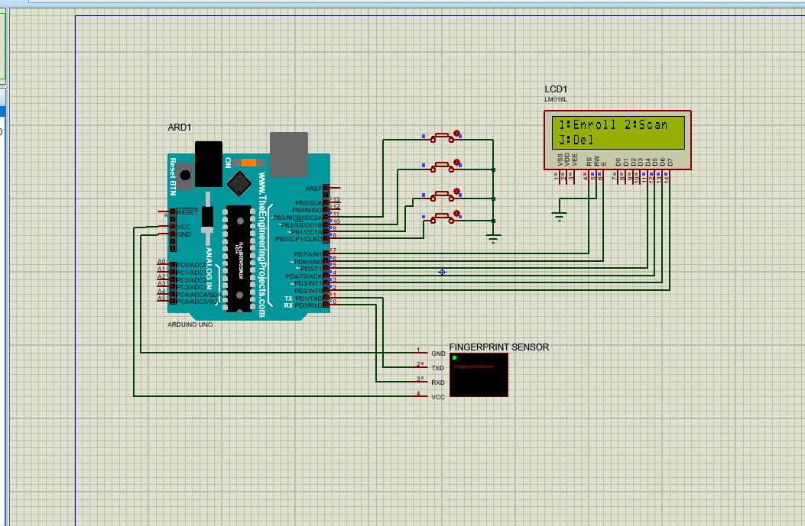

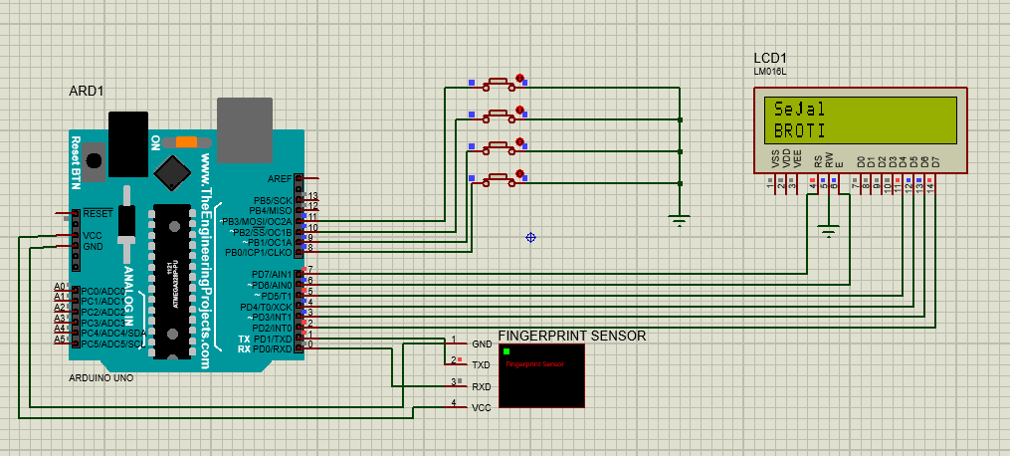

**4) To write a program to get temperature notification using Arduino.**

**1)Schematic:**

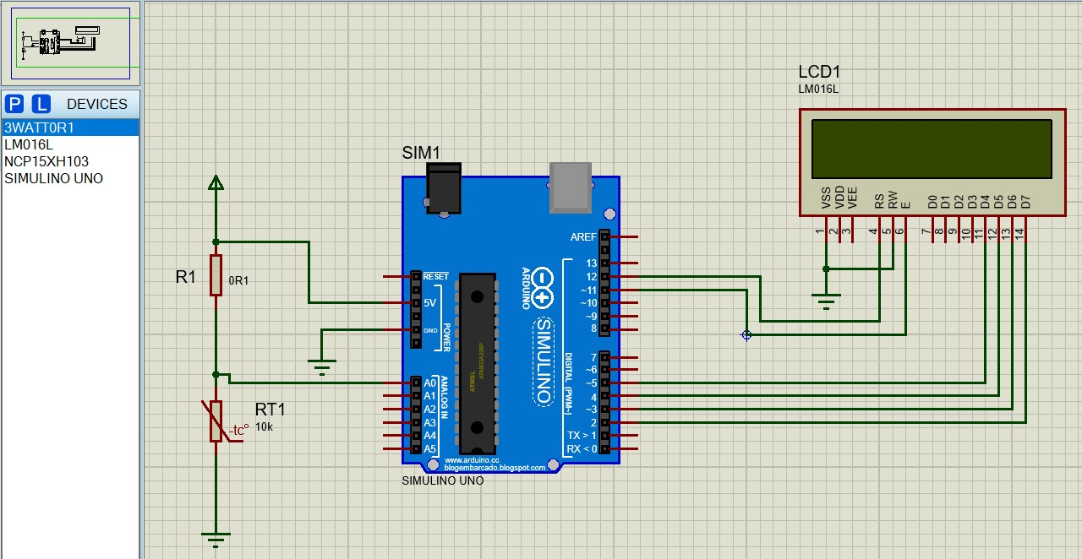

**2)Program:**

#include <LiquidCrystal.h> int THERMISTORPIN = 0, BCOEFFICIENT = 3380;

float THERMISTORNOMINAL = 10000, TEMPERATURENOMINAL = 25, SERIESRESISTOR = 10000;

LiquidCrystal lcd(12, 11, 5, 4, 3, 2); int sample[5]; void setup() { Serial.begin(9600); lcd.begin(16, 2);

}

void loop() {

int i;

float average;

// Take N samples in a row, with a slight delay

for (i = 0; i < 5; i++) {

sample[i] = analogRead(THERMISTORPIN);

delay(10);

}

// Average all the samples out average = 0;

for (i = 0; i < 5; i++) {

average += sample[i];

}

average /= 5;

// Convert the value to resistance average = 1023.0 / average - 1; // Use 1023.0 for floating point division average = SERIESRESISTOR / average;

// Calculate temperature using the Steinhart-Hart equation

float steinhart;

steinhart = average / THERMISTORNOMINAL; // (R/Ro)

steinhart = log(steinhart); // ln(R/Ro) steinhart /= BCOEFFICIENT; // 1/B * ln(R/Ro)

steinhart += 1.0 / (TEMPERATURENOMINAL + 273.15); // + (1/To)

steinhart = 1.0 / steinhart; // Invert steinhart -= 273.15; // Convert to Celsius

// Print debugging information

Serial.print("Analog Value: ");

Serial.println(analogRead(THERMISTORPIN));

Serial.print("Average Resistance: ");

Serial.println(average);

Serial.print("Temperature: ");

Serial.println(steinhart);

// Display on LCD

lcd.setCursor(0, 0); lcd.print("Temp = "); lcd.print((int)steinhart); lcd.print(" C"); delay(500); lcd.clear();

}

**3)OUTPUT:**

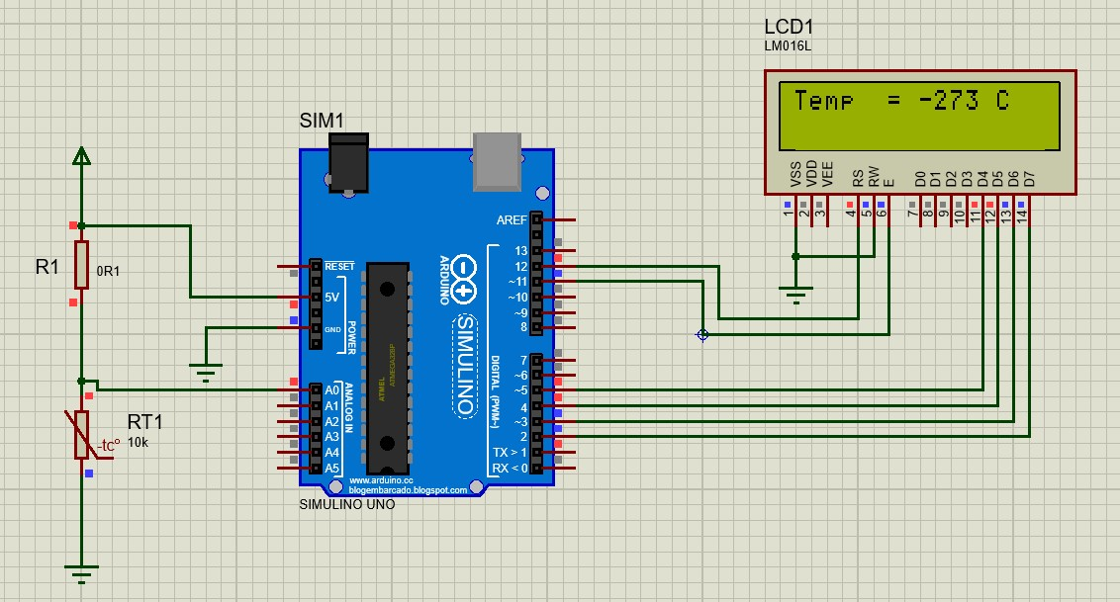

**5)To write a program for LDR to vary the light intensity of LED using Arduino 1.schematic**

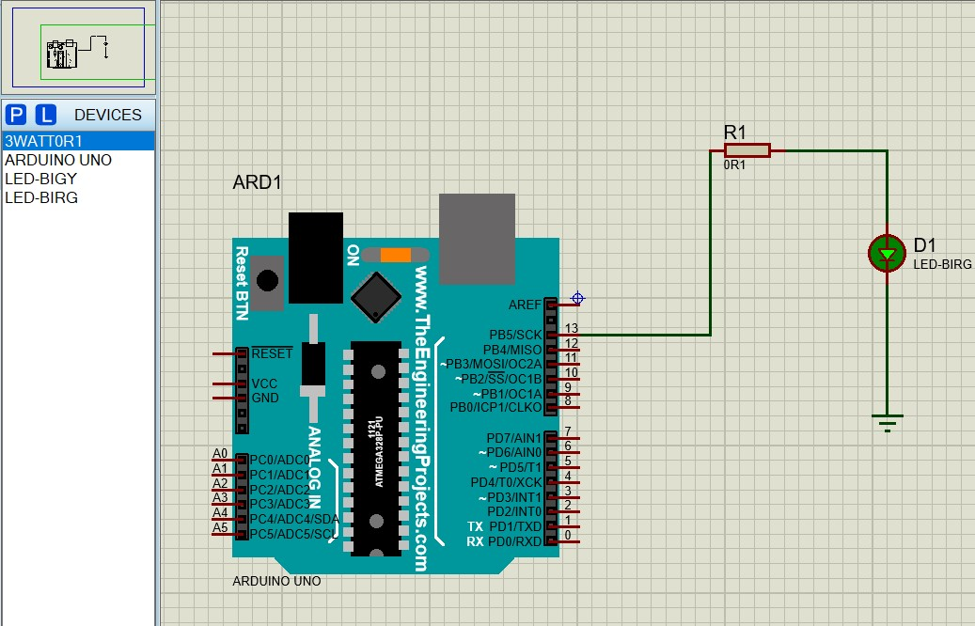

**2.Program : LED.ino**

void setup() { pinMode(13, OUTPUT); // pin 13 - change value if you have LED on diff pin

}

void loop() { digitalWrite(13, HIGH); // set pin 13 to high voltage, turning LED on delay(1000); // wait 1000 milliseconds, or one second. digitalWrite(13, LOW); // set pin 13 to low voltage, or zero. LED off. delay(1000); //wait one second before starting the loop again.

}

**3)Output:**

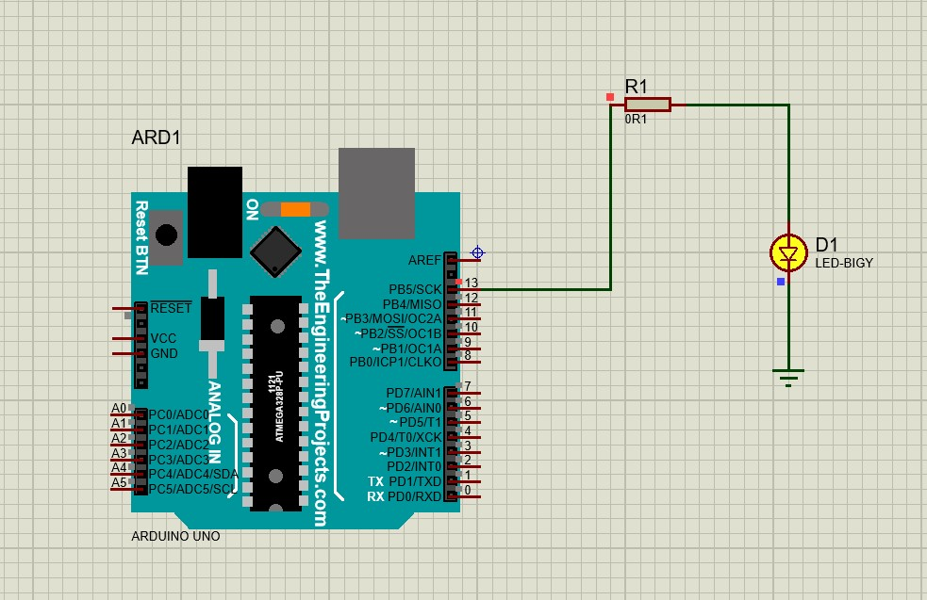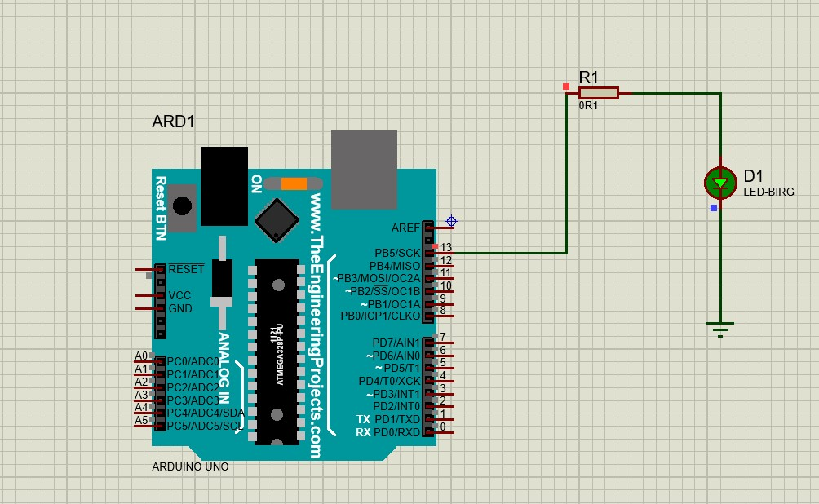

**6) Run some python programs on Pi like:**

**Schematic:**

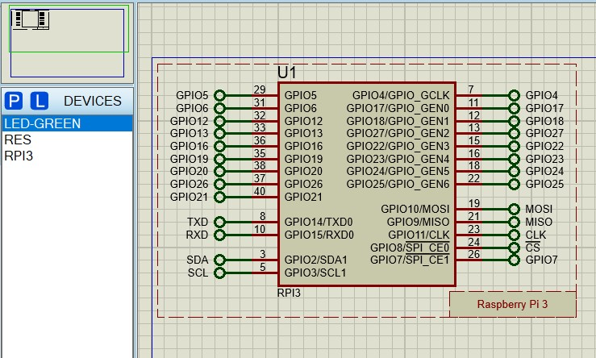

**a) Read your name and print Hello message with name**

**Program :**

from goto import * import time import var import pio import resource import cpu import FileStore import VFP

def peripheral_setup () : # Peripheral Constructors pio.cpu=cpu.CPU () pio.storage=FileStore.FileStore () pio.server=VFP.VfpServer () pio.storage.begin () pio.server.begin (0)

# Install interrupt handlers

def peripheral_loop () :

pass

def main () : # Setup peripheral_setup()

name="Sejal"

print("Hello "+name)

# Infinite loop while 1 :

peripheral_loop() pass

# Command line execution if __name__ == '__main__' :

main()

**OUTPUT:**

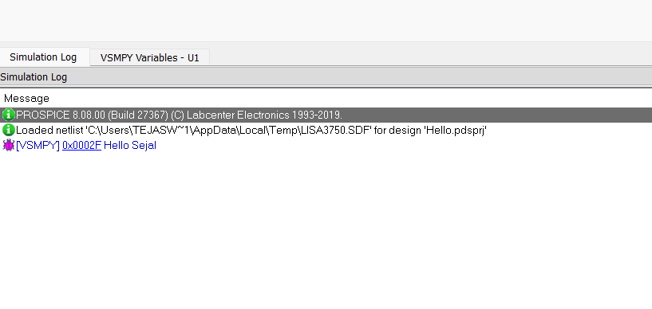

**b)Read two numbers and print their sum, difference, product and division.**

**Program :**

# Modules from goto import * import time import var import pio import resource import cpu import FileStore import VFP

def peripheral_setup () : # Peripheral Constructors pio.cpu=cpu.CPU () pio.storage=FileStore.FileStore () pio.server=VFP.VfpServer () pio.storage.begin () pio.server.begin (0)

# Install interrupt handlers

def peripheral_loop () :

pass

#---CONFIG_END---

# Main function

def main () : # Setup peripheral_setup() num1 = 20 num2 = 10

# Calculate sum, difference, product, and division sum_result = num1 + num2 difference_result = num1 - num2 product_result = num1 * num2

# Print the results print(f"Sum: {sum_result}") print(f"Difference: {difference_result}") print(f"Product: {product_result}") print(f"Division: {division_result}")

# Infinite loop while 1 : peripheral_loop() pass

# Command line execution if __name__ == '__main__' :

main()

**OUTPUT:**

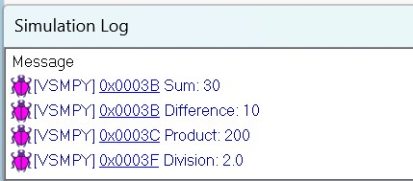

**c) Word and character count of a given string.**

**Program:**

from goto import * import time import var import pio import resource import cpu import FileStore import VFP

def peripheral_setup () : # Peripheral Constructors pio.cpu=cpu.CPU () pio.storage=FileStore.FileStore () pio.server=VFP.VfpServer () pio.storage.begin () pio.server.begin (0)

# Install interrupt handlers

def peripheral_loop () :

pass

#---CONFIG_END---

# Main function def main () : # Setup peripheral_setup() str="Hello World" character_count = len(str) word_count = len(str.split()) print("Character count: ",character_count) print("word count: ",word_count)

# Infinite loop while 1 :

peripheral_loop() pass

# Command line execution if __name__ == '__main__' :

main()

**OUTPUT:**

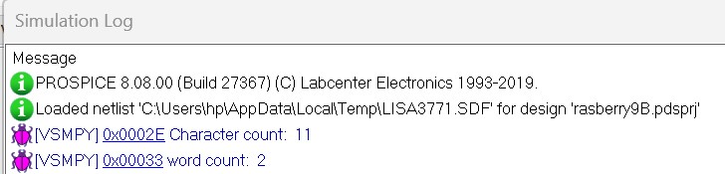

**d)Area of a given shape (rectangle, triangle and circle) reading shape and appropriate values from standard input.**

**Program:**

from goto import * import time import var import pio import resource import math import cpu import FileStore import VFP def peripheral_setup () : # Peripheral Constructors pio.cpu=cpu.CPU () pio.storage=FileStore.FileStore () pio.server=VFP.VfpServer () pio.storage.begin () pio.server.begin (0)

def peripheral_loop () :

pass def main () :

peripheral_setup() def calculate_rectangle_area(width, height):

return width * height def calculate_triangle_area(base, height):

return 0.5 * base * height def calculate_circle_area(radius): return math.pi * radius ** 2

rectangle_width = 5

rectangle_height = 10

triangle_base = 6 triangle_height = 4

circle_radius = 3

# Calculate areas rectangle_area = calculate_rectangle_area(rectangle_width, rectangle_height) triangle_area = calculate_triangle_area(triangle_base, triangle_height) circle_area = calculate_circle_area(circle_radius)

# Print the results print(f"The area of the rectangle is: {rectangle_area}") print(f"The area of the triangle is: {triangle_area}") print(f"The area of the circle is: {circle_area:.2f}")

while 1 : peripheral_loop() pass

# Command line execution if __name__ == '__main__' :

main()

**2. OUTPUT:**

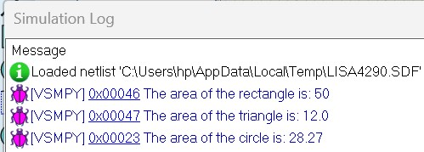

**7) Run some python programs on Pi like:**

**a) Handle Divided by Zero Exception.**

**1.Program :**

# Modules from goto import * import time import var import pio import resource import math import cpu import FileStore import VFP

def peripheral_setup () : # Peripheral Constructors pio.cpu=cpu.CPU () pio.storage=FileStore.FileStore () pio.server=VFP.VfpServer () pio.storage.begin () pio.server.begin (0)

# Install interrupt handlers

def peripheral_loop () :

pass

#---CONFIG_END---

# Main function def main () : # Setup peripheral_setup() numerator = 10 denominator = 0 # Change this to a non-zero value to see a successful division

# Attempt to perform the division

try:

result = numerator / denominator print(f"The result of {numerator} / {denominator} is: {result}") except ZeroDivisionError:

print("Error: Division by zero is undefined.")

# Infinite loop while 1 : peripheral_loop() pass

# Command line execution if __name__ == '__main__' :

main()

**2.OUTPUT:**

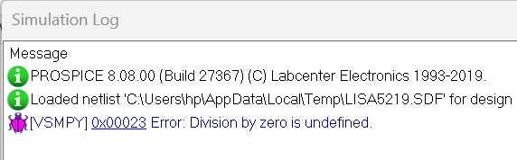

**b) Print current time for 10 times with an interval of10seconds.**

**1. Program:**

from goto import * import time import var import pio import resource

# Peripheral Configuration Code (do not edit)

#---CONFIG_BEGIN--- import cpu import FileStore import VFP

def peripheral_setup () : # Peripheral Constructors pio.cpu=cpu.CPU () pio.storage=FileStore.FileStore () pio.server=VFP.VfpServer () pio.storage.begin () pio.server.begin (0)

# Install interrupt handlers

def peripheral_loop () :

pass

#---CONFIG_END---

# Main function def main(): # Setup peripheral_setup() # Print current time 10 times with an interval of 10 seconds for i in range(10):

current_time = time.strftime("%Y-%m-%d %H:%M:%S", time.localtime()) print(f"Iteration {i + 1}: Current time is {current_time}") time.sleep(10) # Wait for 10 seconds

# Infinite loop while 1: peripheral_loop()

pass

# Command line execution if _name_ == '_main_':

main()

**2.OUTPUT:**

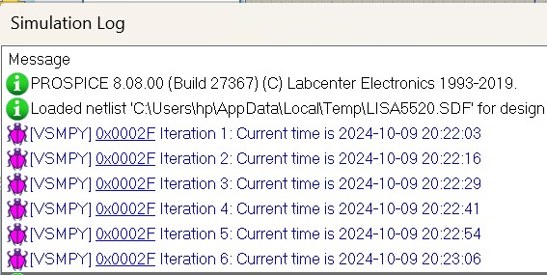

**c) Read a fileline byline and print the word count of each line**

**1. Program:**

# Modules from goto import * import time import var import pio import resource import math

# Peripheral Configuration Code (do not edit)

#---CONFIG_BEGIN--- import cpu import FileStore import VFP

def peripheral_setup () : # Peripheral Constructors pio.cpu=cpu.CPU () pio.storage=FileStore.FileStore () pio.server=VFP.VfpServer () pio.storage.begin () pio.server.begin (0)

# Install interrupt handlers

def peripheral_loop () :

pass # Main function

def main () : # Setup peripheral_setup() filename = r'C:\Users\hp\OneDrive\Desktop\arduino pract\Example.txt' try: with open(filename, 'r') as file: for line_number, line in enumerate(file, start=1): # Count the number of words in the line word_count = len(line.split()) print(f"Line {line_number}: {word_count} words") except FileNotFoundError:

print(f"Error: The file '{filename}' does not exist.")

# Infinite loop while 1 : peripheral_loop() pass

# Command line execution if __name__ == '__main__' :

main()

**Example.txt**

Welcome to our college.

Our college is providing different courses.

**2. OUTPUT:**

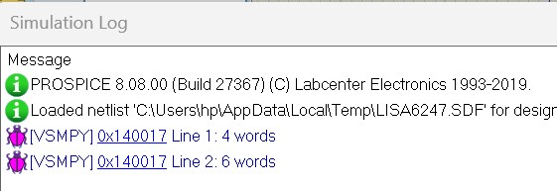

**8) Run some python programs on Pi like**

**a) Light an LED through Python program**

**1.Schematic:**

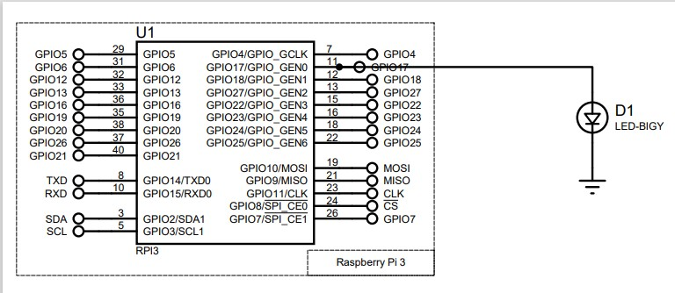

**2.Program:**

#!/usr/bin/env python3 import RPi.GPIO as GPIO import time

# GPIO setup

LED_PIN = 17

def peripheral_setup():

GPIO.setmode(GPIO.BCM)

GPIO.setup(LED_PIN, GPIO.OUT)

def peripheral_loop():

GPIO.output(LED_PIN, GPIO.HIGH)

time.sleep(1)

GPIO.output(LED_PIN, GPIO.LOW)

time.sleep(1)

def main():

try:

peripheral_setup() while True:

peripheral_loop() except KeyboardInterrupt:

GPIO.cleanup()

if __name__ == '__main__':

main()

**3.Output:**

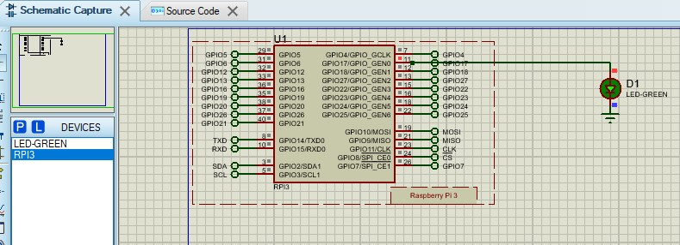

**b) Get input from two switches and switch on corresponding LEDs 1.Schematic:**

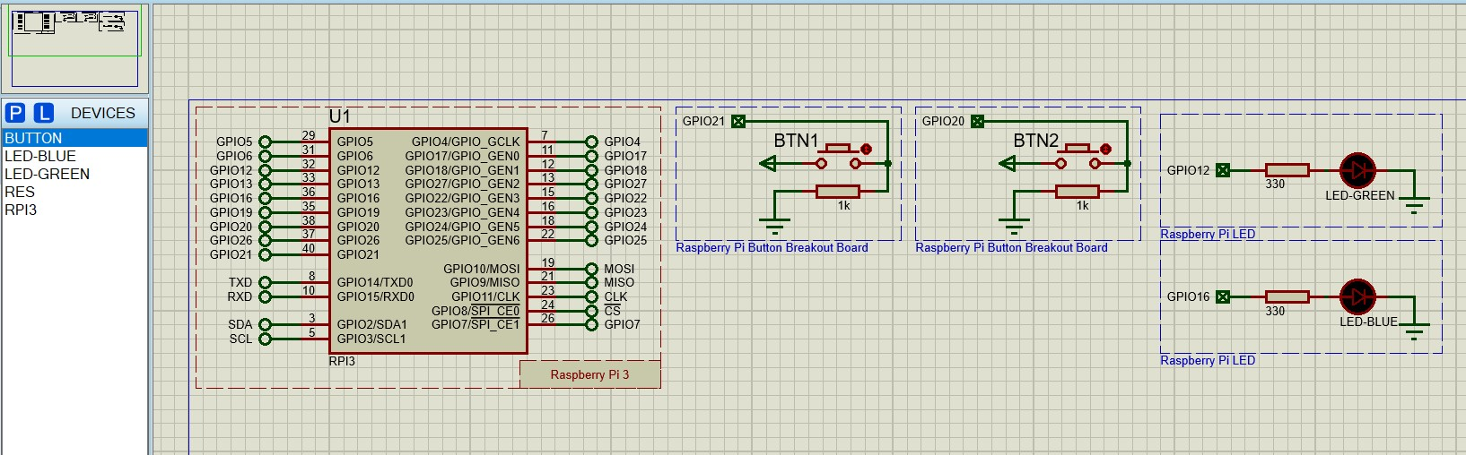

**2.Program:**

import RPi.GPIO as GPIO import time

# Set the mode to BCM

GPIO.setmode(GPIO.BCM)

# Pin configuration switch1_pin = 21 # Switch 1 switch2_pin = 20 # Switch 2 led1_pin = 16 # LED 1 (Green) led2_pin = 12 # LED 2

# Setup pins for switches as input with pull-down resistors

GPIO.setup(switch1_pin, GPIO.IN, pull_up_down=GPIO.PUD_DOWN) GPIO.setup(switch2_pin, GPIO.IN, pull_up_down=GPIO.PUD_DOWN)

# Setup pins for LEDs as output

GPIO.setup(led1_pin, GPIO.OUT)

GPIO.setup(led2_pin, GPIO.OUT)

try: while True:

# Read input from switches if GPIO.input(switch1_pin) == GPIO.HIGH:

GPIO.output(led1_pin, GPIO.HIGH) # Turn on LED 1

else:

GPIO.output(led1_pin, GPIO.LOW) # Turn off LED 1

if GPIO.input(switch2_pin) == GPIO.HIGH:

GPIO.output(led2_pin, GPIO.HIGH) # Turn on LED 2

else:

GPIO.output(led2_pin, GPIO.LOW) # Turn off LED 2

time.sleep(0.1) # Add a small delay to prevent bouncing issues

except KeyboardInterrupt:

# Clean up GPIO when the program is terminated

GPIO.cleanup()

**3.OUTPUT:**

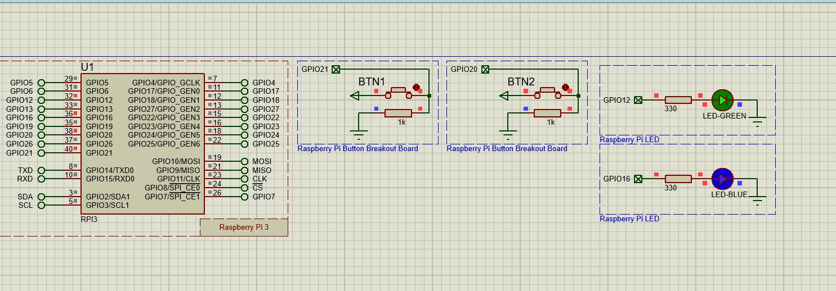

**c) Flash an LED at a given on time and off time cycle, where the two times are taken from a file.**

**1. Schematic :**

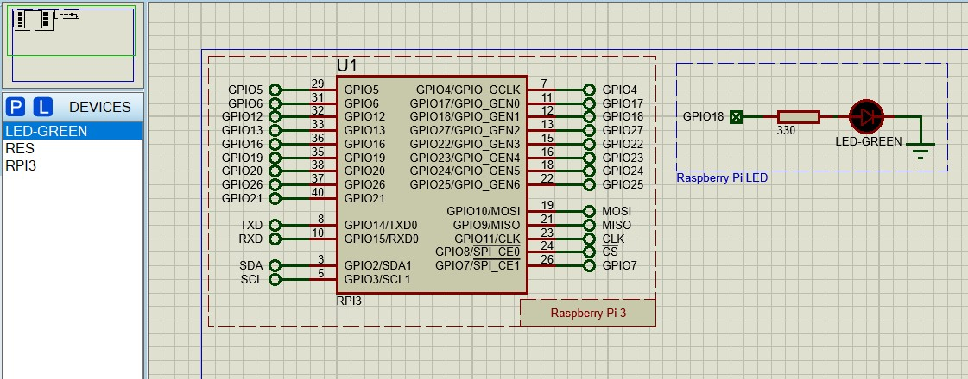

**2.Program: Main.py** import RPi.GPIO as GPIO import time

# Set up GPIO

LED_PIN = 18 # Replace with your actual pin number

GPIO.setmode(GPIO.BCM)

GPIO.setup(LED_PIN, GPIO.OUT)

# Function to read configuration from file def read_config(filename):

config = {} try:

with open(filename, 'r') as file:

for line in file:

key, value = line.strip().split('=') config[key] = float(value) except FileNotFoundError:

print(f"Error: The file '{filename}' does not exist.") return config

# Main function def main():

config = read_config('led_config.txt')

on_time = config.get('on_time', 1) # Default to 1 second if not found off_time = config.get('off_time', 1) # Default to 1 second if not found

try: while True:

GPIO.output(LED_PIN, GPIO.HIGH) # Turn LED on time.sleep(on_time) # Wait for the on time GPIO.output(LED_PIN, GPIO.LOW) # Turn LED off time.sleep(off_time) # Wait for the off time except KeyboardInterrupt:

print("Program interrupted. Cleaning up...")

finally:

GPIO.cleanup() # Clean up GPIO settings

if __name__ == "__main__":

main()

**led_config.txt:**

on_time=1 # Time in seconds to keep the LED on off_time=0.5 # Time in seconds to keep the LED off

**OUTPUT:**

